(a) Mass spectrum of peak a in the TSHE
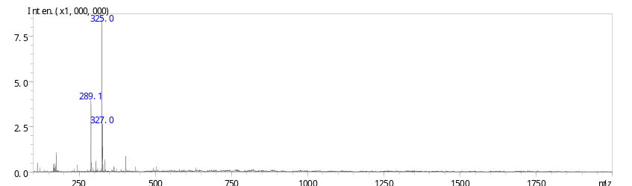
(b) Mass spectrum of peak c in the TSHE
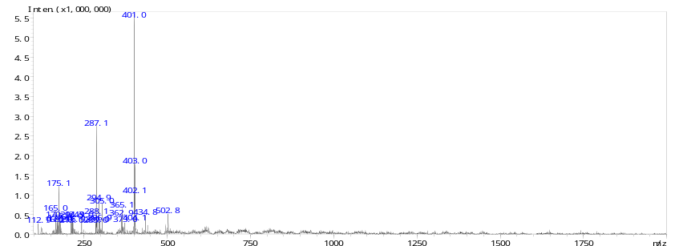
(c) Mass spectrum of peak d
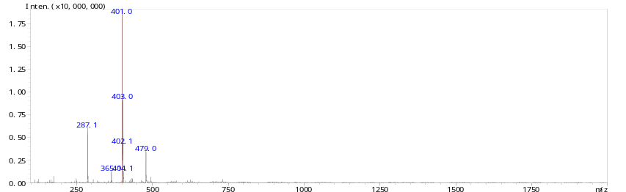
Figure S1. Mass spectra of peaks a, c, and d in the TSHE. (A) Mass spectrum of peak a. (B) Mass spectrum of peak c. (C) Mass spectrum of peak d. Peaks a, c, d match the structure of the same number in Figure 1.

