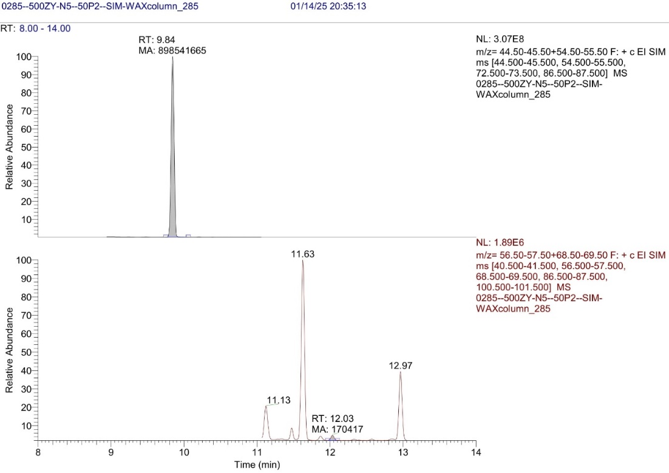

**Figure S17.** Olive oil sample N5 with 50 mg/l of P2 (top) and DMB (bottom) chromatogram, 1st injection.