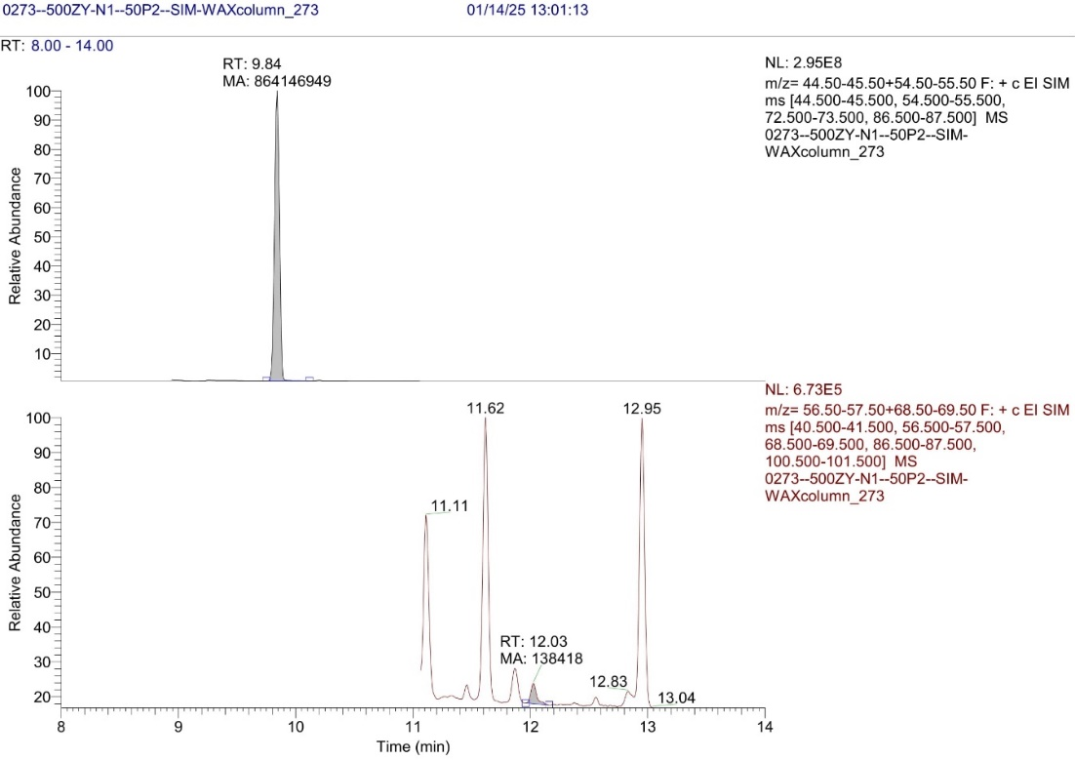

**Figure S13.** Olive oil sample N1 with 50 mg/l of P2 (top) and DMB (bottom) chromatogram, 1st injection.