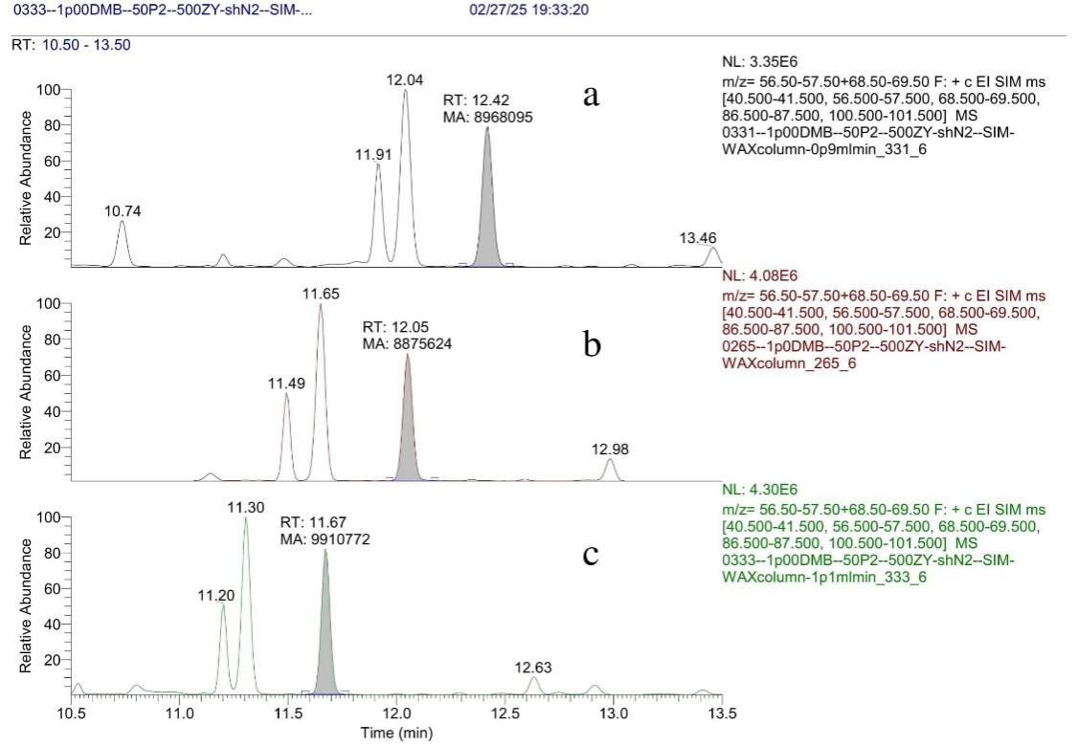

**Figure S11:** Robustness control for 1 000 µg/l DMB samples at different mobile phase flow rate: 0.9 ml/min (**a**), 1.0 ml/min (**b**), 1.1 ml/min (**c**).