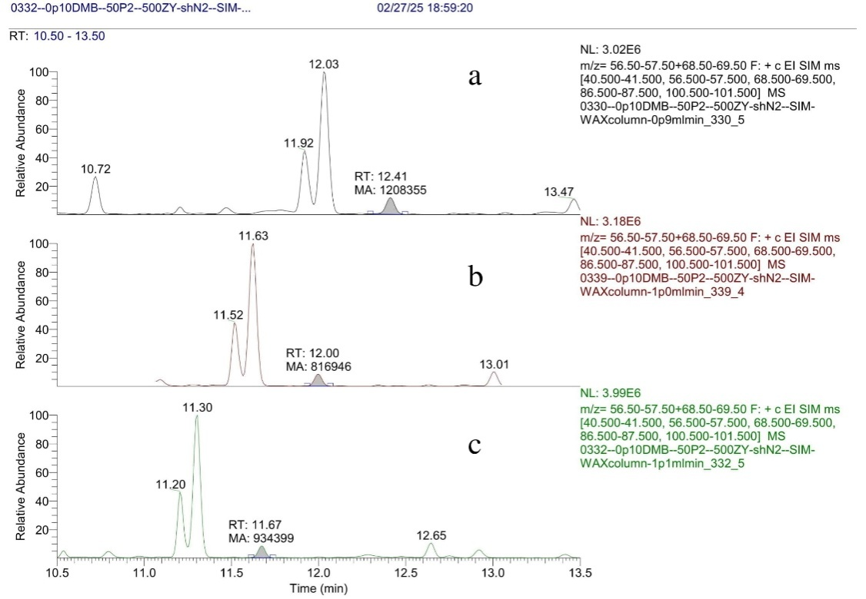

**Figure S10:** Robustness control for 100 µg/L DMB samples at different mobile phase flow rate: 0.9 ml/min (**a**), 1.0 ml/min (**b**), 1.1 ml/min (**c**).