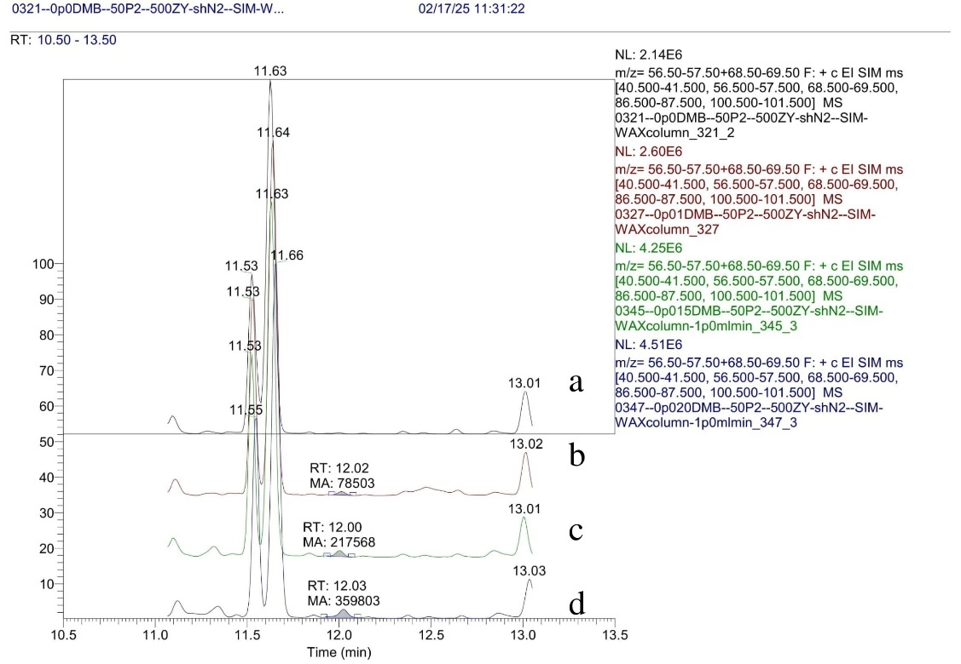

**Figure S9:** Determination of LOD using chromatography data. Blank Olive oil sample (**a**), with 10 μg/L (**b**), 15 μg/l (**c**) and 20 μg/l (**d**) of DMB sample chromatograms**.**