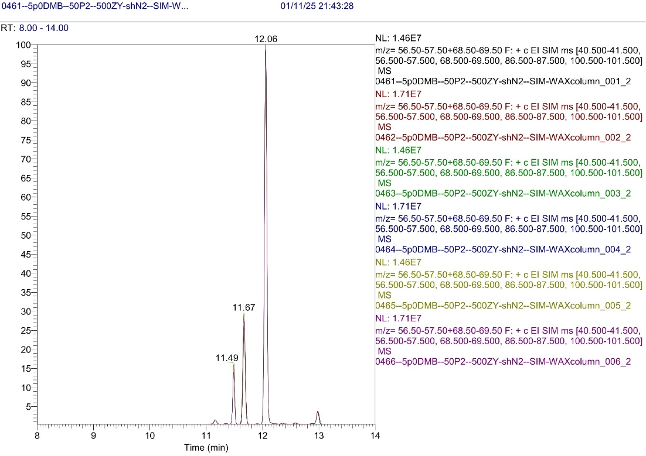

**Figure S8:** Accuracy control for 5000 µg/l DMB (RT = 12.06 min) samples in blank olive oil