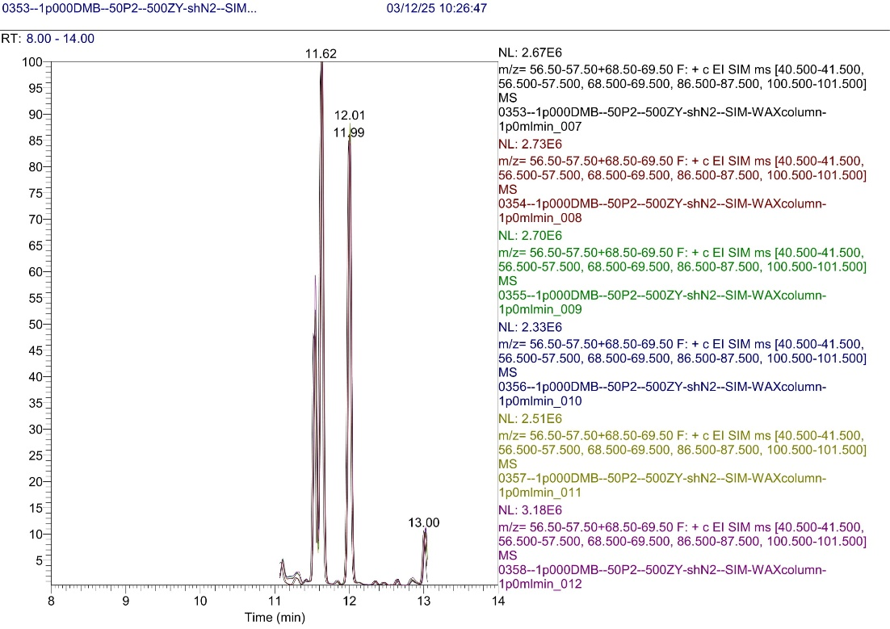

**Figure S7:** Accuracy control for 1000 µg/l DMB (RT = 12.01 min) samples in blank olive oil