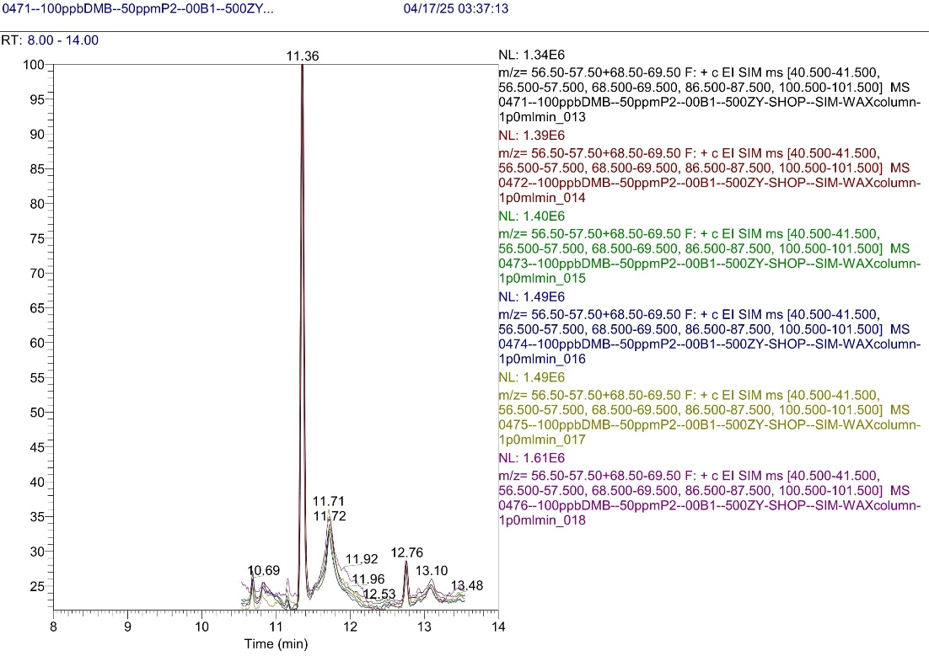

**Figure S6:** Accuracy control for 100 µg/l DMB samples (RT = 11.71 min) in blank olive oil