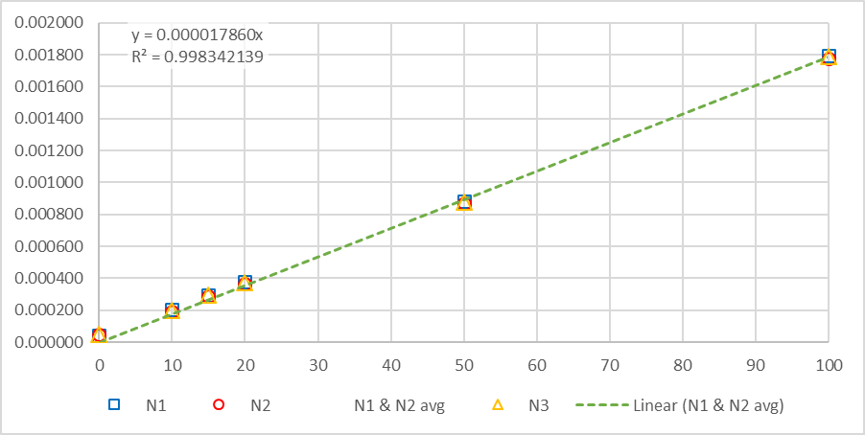  
**Figure S5:** Calibration points for a range of 0 – 100 µg/l of DMB.