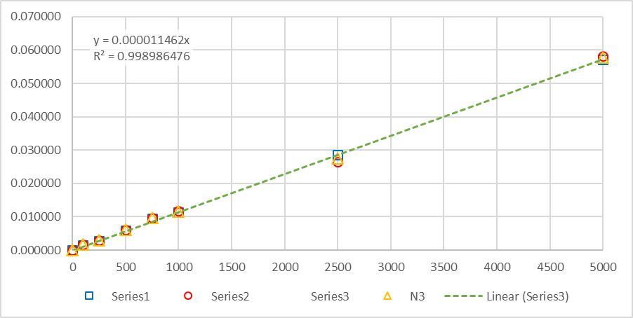  
**Figure S4:** Calibration points for a range of 10 – 5000 µg/l of DMB (passes through the origin).