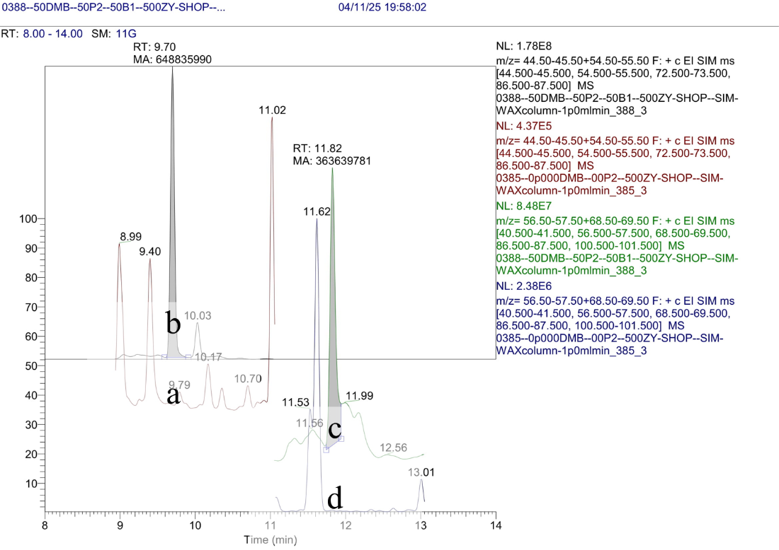  
**Figure S3:** Specificity measurements for 2-pentanol and DMB in standard mixture solution: (**a**) pure water, (**b**) 50 mg/l 2-pentanol, (**c**) pure water, (**d**) 50 mg/l DMB.