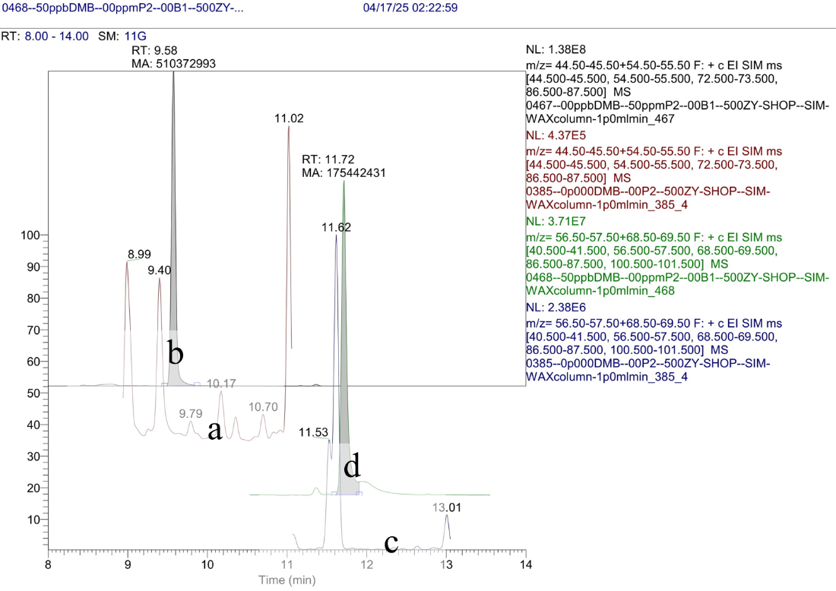  
**Figure S2:** Specificity measurements for 2-pentanol and DMB in blank olive oil: (**a**) absence of 2‑pentanol in blank olive oil, (**b**) 50 mg/l 2-pentanol in blank olive oil, (**c**) absence of DMB in blank olive oil, (**d**) 50 mg/l DMB in blank olive oil.