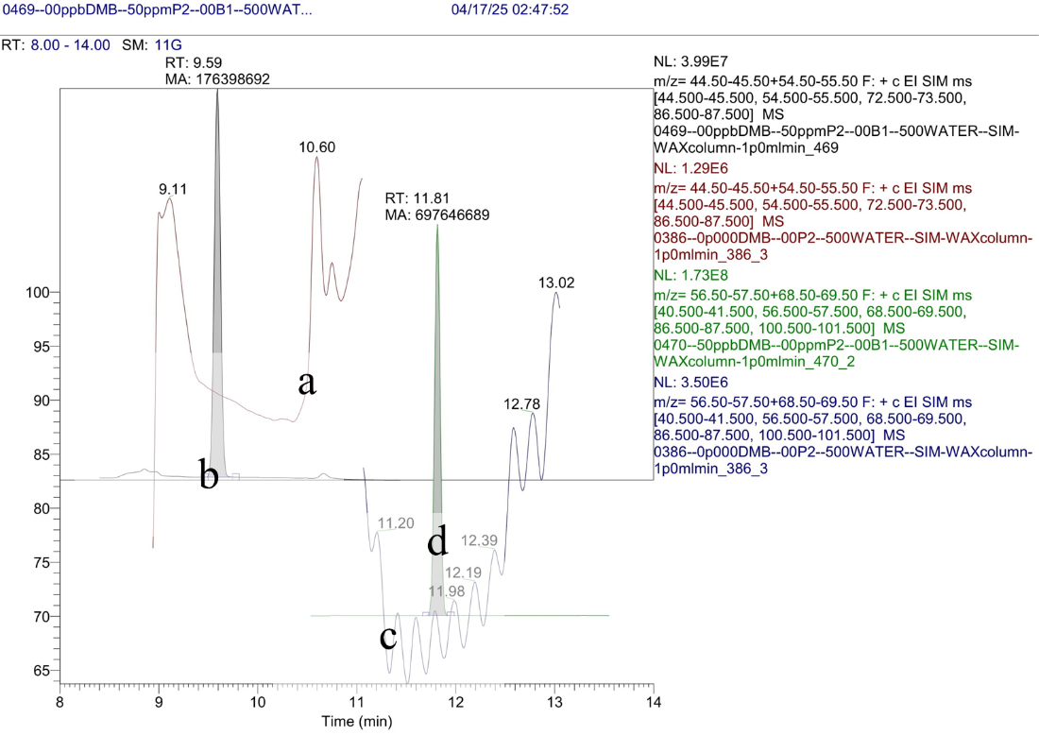  
**Figure S1:** Specificity measurements for 2-pentanol and DMB in water: (**a**) absence of 2‑pentanol in water, (**b**) 50 mg/l 2-pentanol in water, (**c**) absence of DMB in water, (d) 50 mg/l DMB in water.