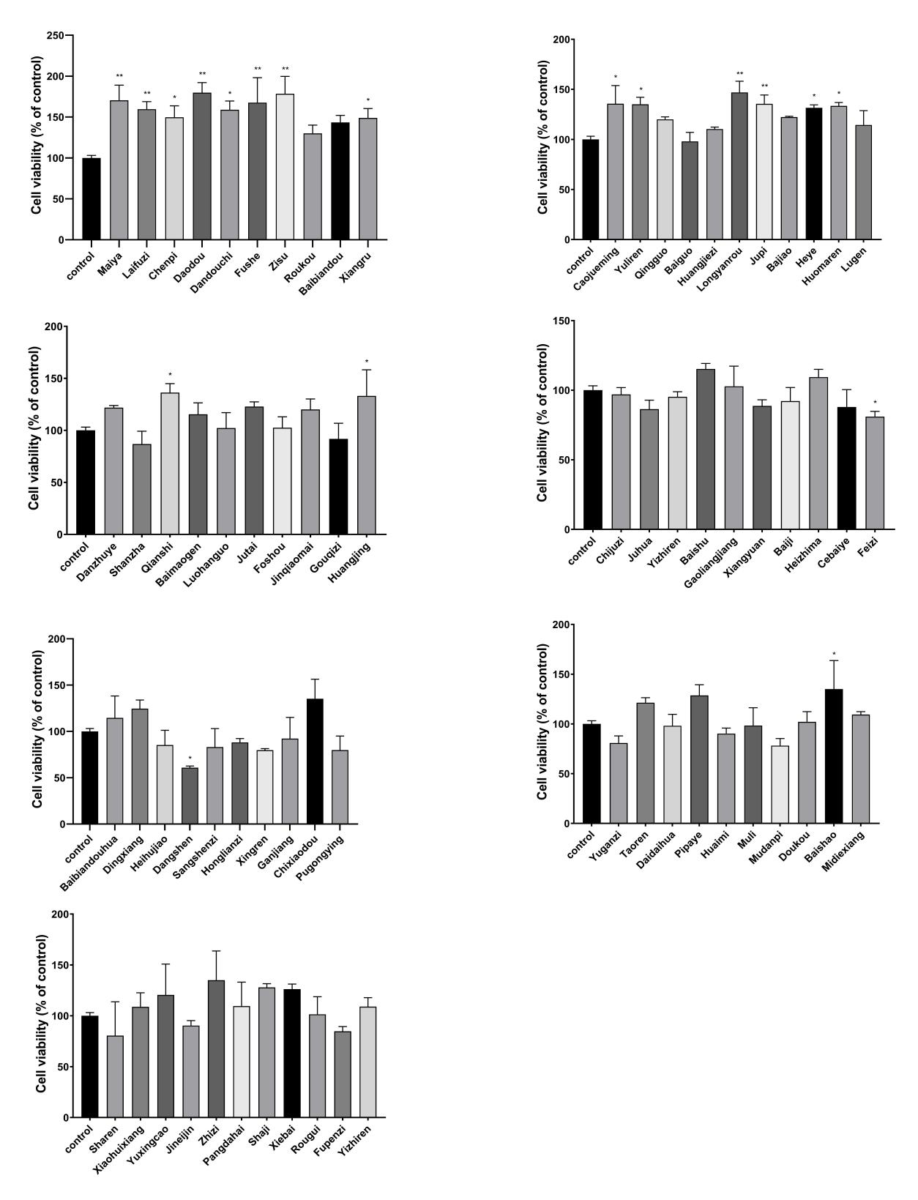

**Supplementary Figure. 1** Determination of cell viability in NIH-3T3 cells pretreated with CHM extracts.