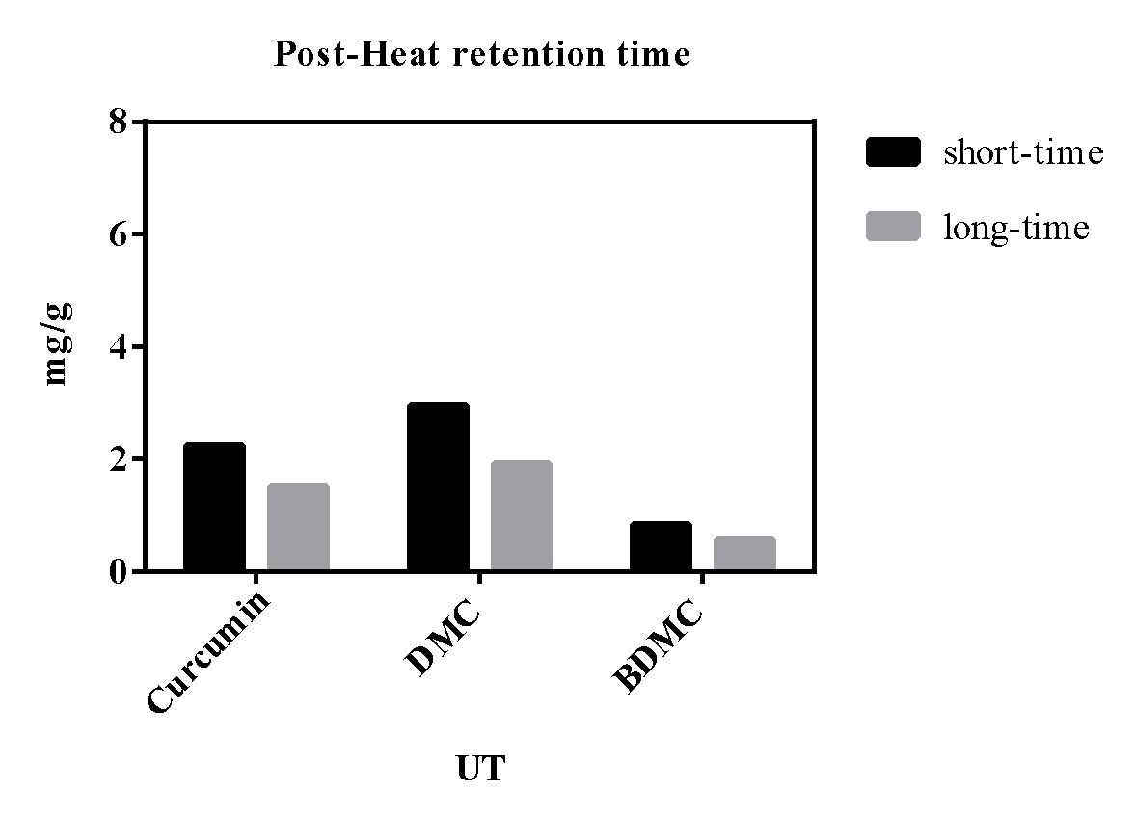

**Supplementary Figure 5. Comparison of curcuminoids change in unfermented turmeric (UT) during Post-Heat retention time after autoclave.**