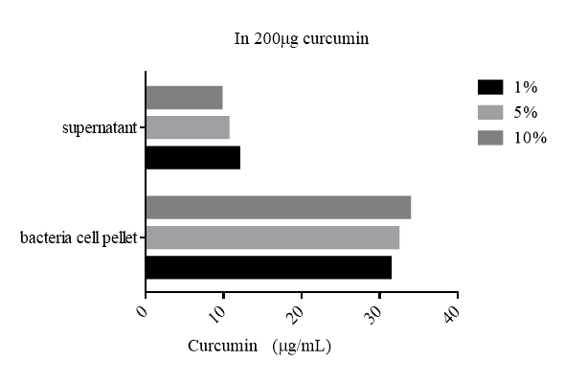

**Supplementary Figure S4. Effect of various percentage of *L. rhamnosus* FN7 biomass cell wall binding property in curcumin medium.**