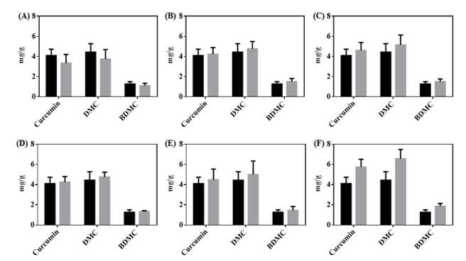

**Supplementary Figure 3. Quantification of curcuminoids in unfermented (black bar) and fermented turmeric (grey bar) by different BCRC LAB strains.** (A) *B. longum* BCRC 11847 (B) *L. rhamnosus* GG BCRC 16000 (C) *L. gasseri* BCRC 14619 (D) *L. reuteri* BCRC 14625 (E) *L. rhamnosus* BCRC 10940 (F) *L. fermentum* BCRC 12190