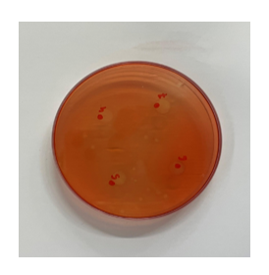

Supplementary Figure 2. Cellulase activity test of *L. rhamnosus* FN7.