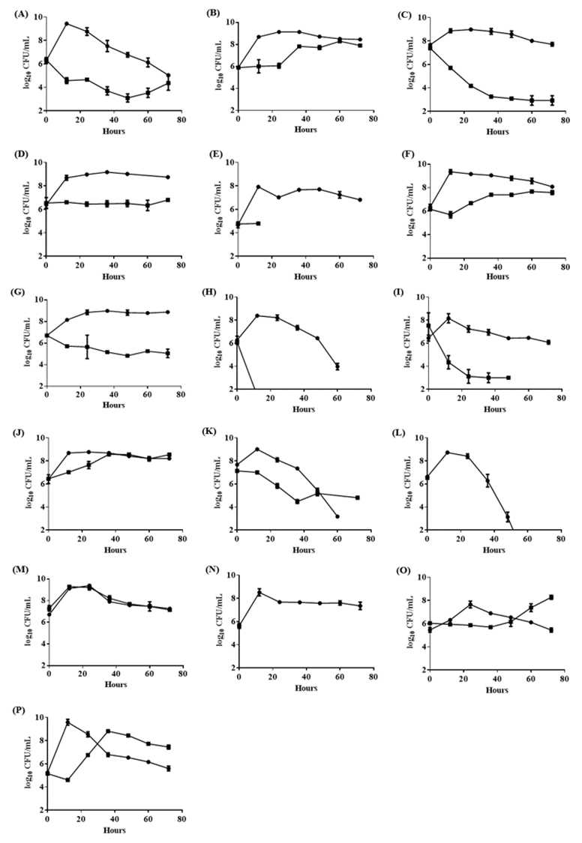

**Supplementary Figure S1.** **Growth curve of different BCRC LAB strains in 3% turmeric conditions. MRS medium (circle) and MRS medium containing 3% turmeric (square).** (A) *L. gasseri* BCRC 14619, (B) *L. rhamnosus* GG BCRC 16000, (C) *Lactobacillus* sp. MCL40