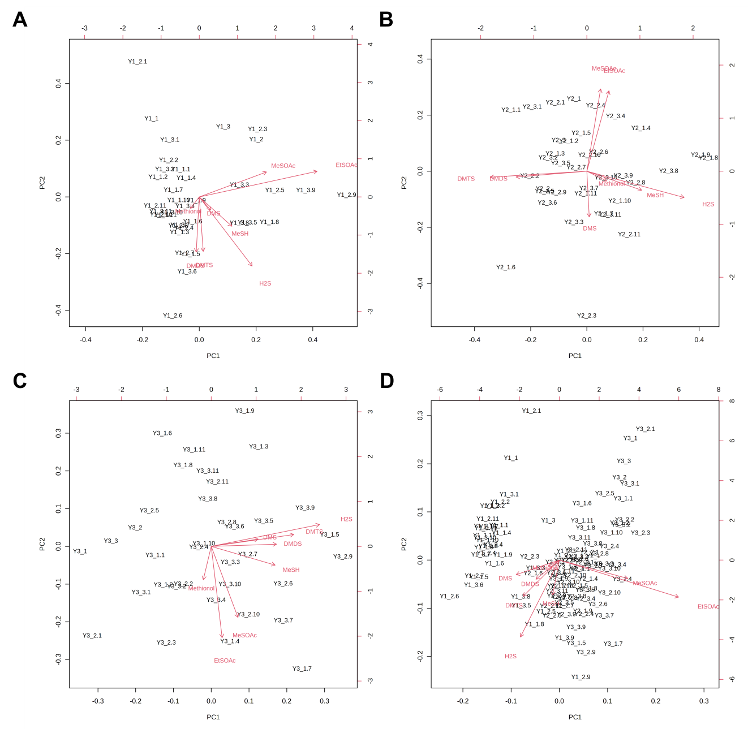
Appendix A supplementary data Figure 1S. Principal component analysis (biplot) of sulfur volatiles in differently treated of Pinot noir wines. (a) Year 1 samples, shown as Y1; (b) Year 2 samples, shown as Y2; (c) Year 3 samples, shown as Y3; (d) All samples. Different number _1-_11 means I NT 0N, I T 0N, D NT 0N, D T 0N, I NT FN, I T FN, D NT FN, D T FN, I NT SN, I T SN, D NT SN, D T SN.

