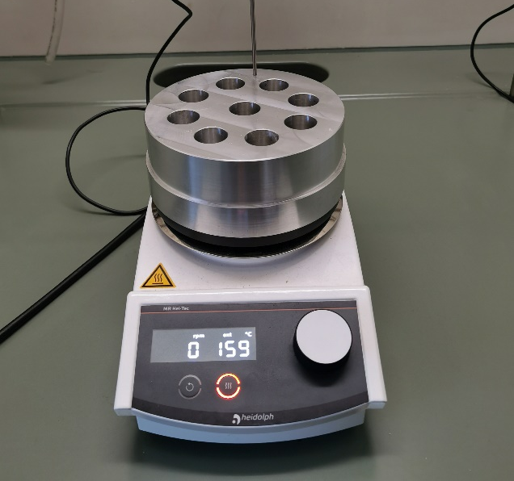
Figure S1: Heating block (in-house manufactured) with a magnetic stirrer (Hei-Tec with external temperature sensor Pt100, Heidolph Instruments, Germany).

