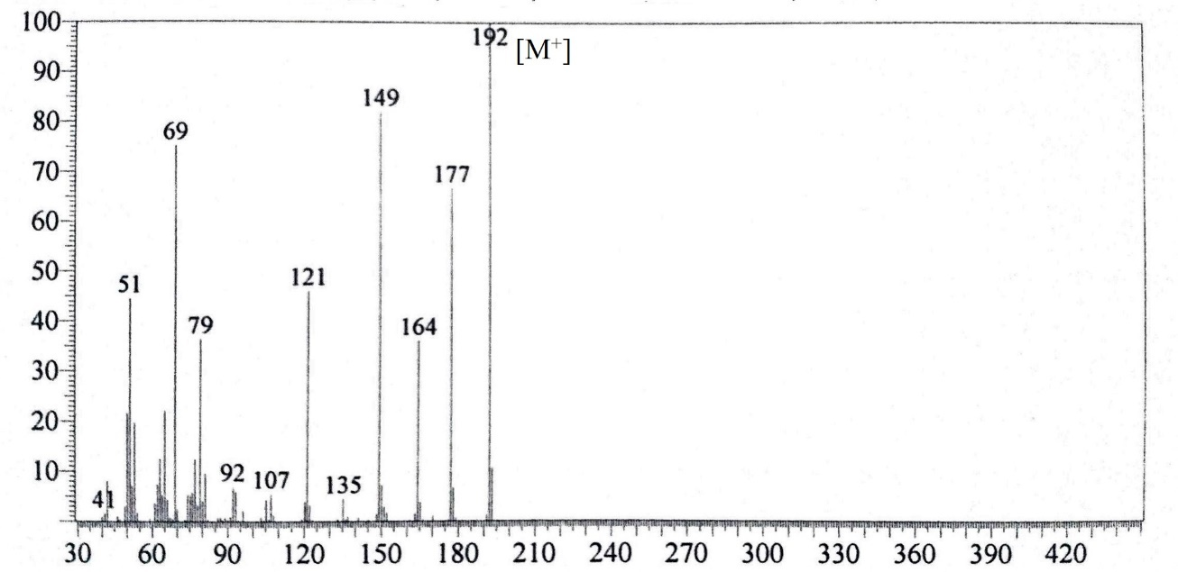

(a)

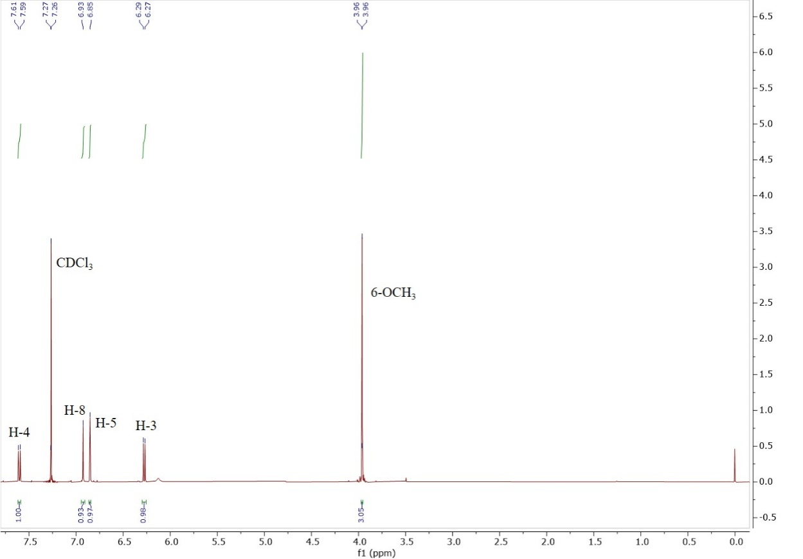



(b)

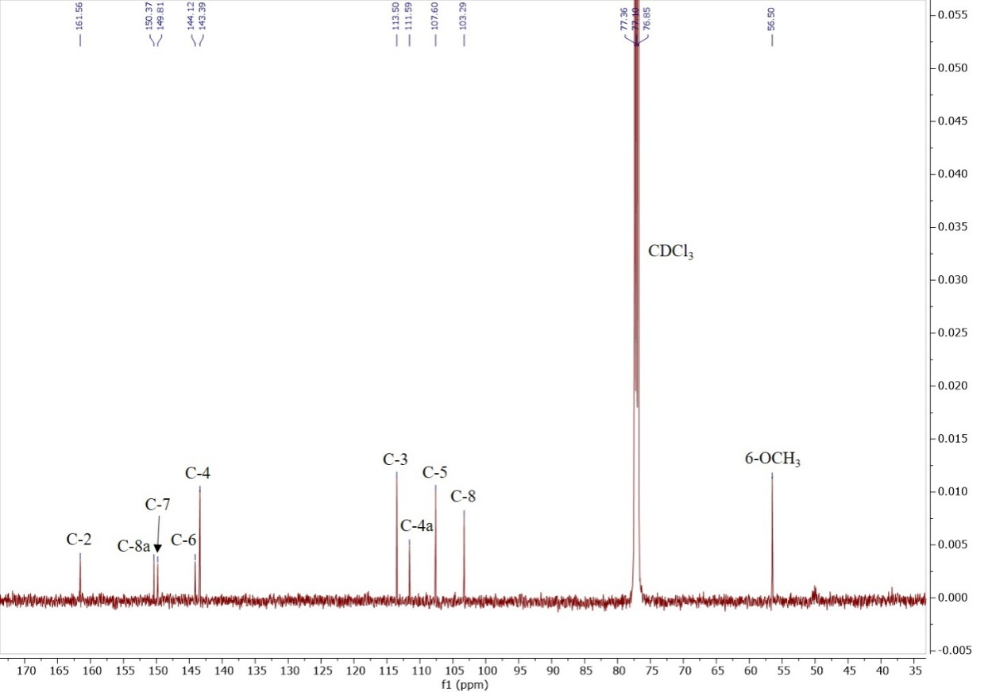

(c)

Figure S3: (a) EI-MS (b) 1H NMR Spectrum (c) 13C NMR Spectrum ofscopoletin, **3**.