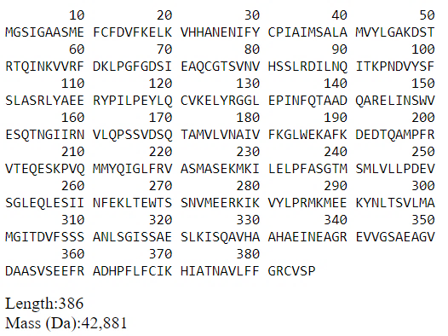
Figure S1: Amino acid sequence of chicken ovalbumin (UniProt ID: P01012)

